EXPERIMENT 16 – CLONE A VIRTUAL MACHINE
Aim:
To create a clone of a Virtual Machine and test the cloned VM.
Procedure:
- Open VMware Workstation and select the required VM.
- Shut down the VM.
- Select Manage → Clone.
- Choose the appropriate cloning option.
- Select the location and name for the cloned VM.
- Complete the cloning process.
- Open and power on the cloned VM.
- Verify the operating system, files, and configurations in the cloned VM.
- Execute simple Unix commands such as pwd, ls, and uname.
- Verify that the cloned VM operates independently of the original VM.
Output:
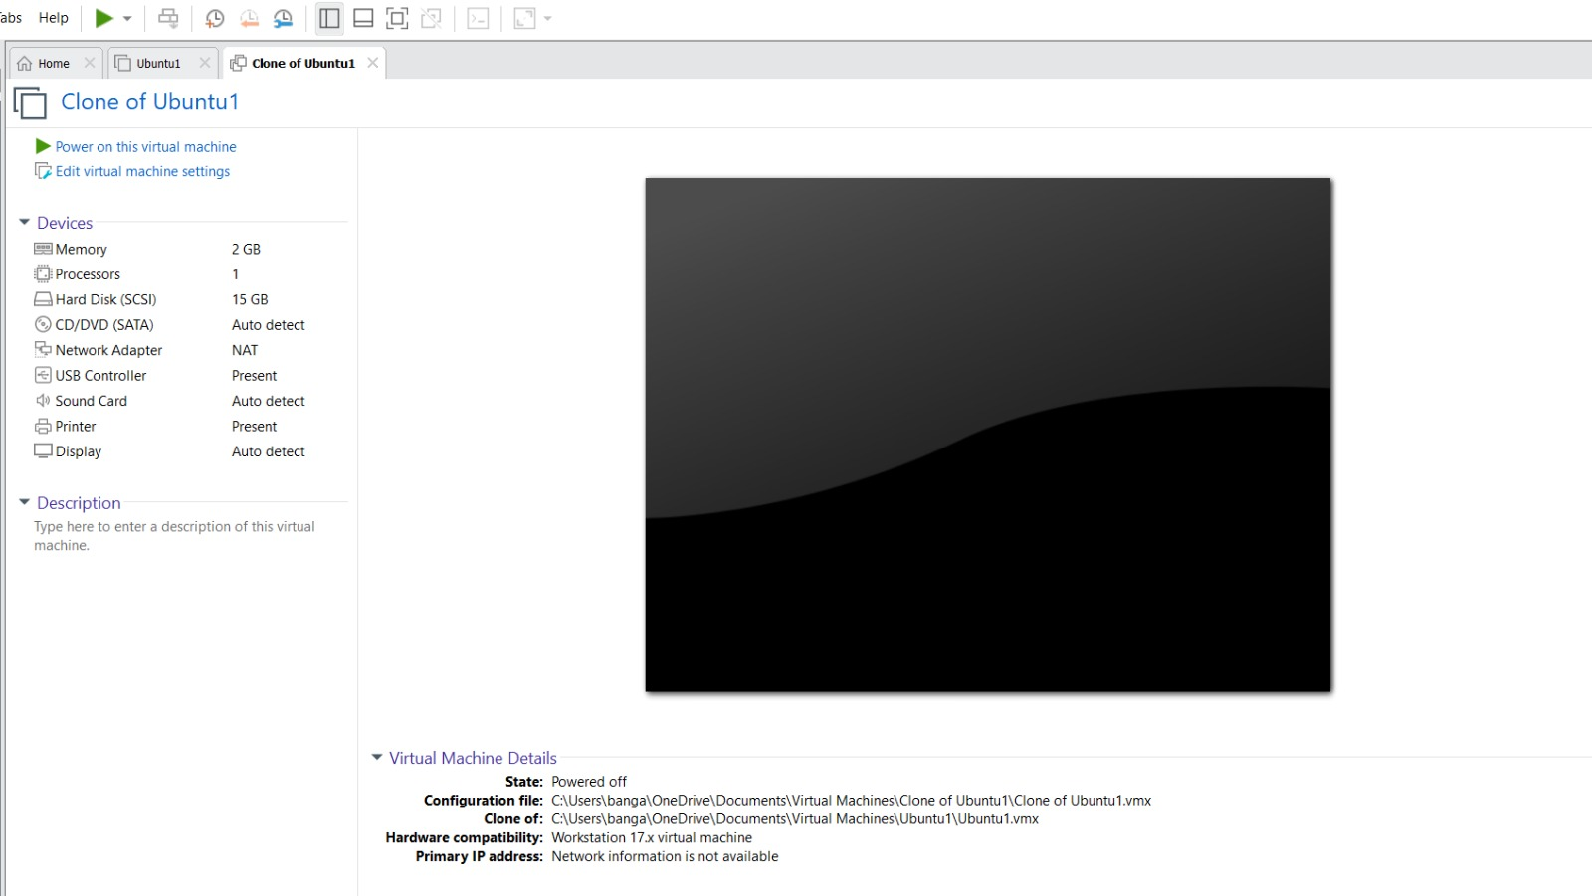
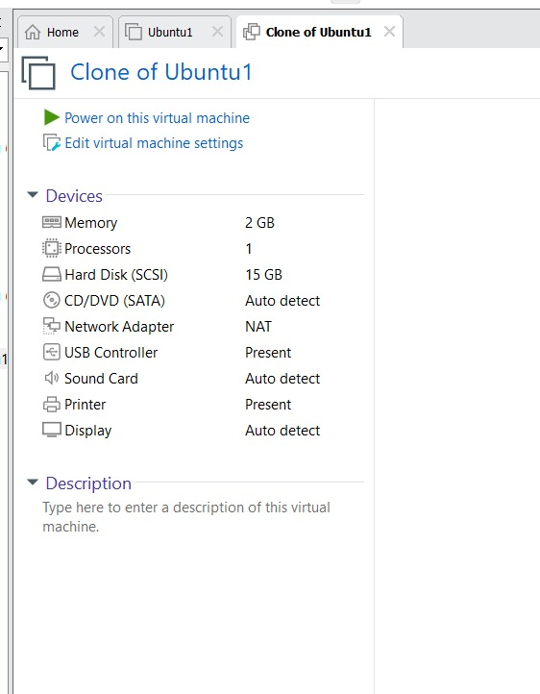

Result:
Thus, a clone of the Virtual Machine was successfully created and tested.

